# Cashier Application (POS System) for CRISTY’S LOVE BURGER HUB

Aryan Jung Karki, Asmit Gahatraj B.K., Rishav Kumar Shah, Shadip Kumar Joshi

B.Sc. (Hons.) Computing, Softwarica College of IT and E-commerce, Coventry University

ST4008CEM: Computing Activity Led Learning Project 1

Giriraj Rawat

July 26, 2022

# TABLE OF CONTENTS

Cashier Application (POS System) for CRISTY’S LOVE BURGER HUB 5

Introduction 5

Aim 7

Objectives 7

Problem Statement 8

Features 10

Functional Requirements 12

Non-Functional Requirements 13

Scope 14

Development Methodology 16

Methodology 16

Tools and Technologies 18

Conceptual Diagram 19

System Architecture 20

Project Plan 21

Prototypes 22

Developed System 27

Login UI 27

Registration UI 29

Product Details UI 31

Update/Delete UI 33

POS UI 35

System Testing 37

Version Control 43

Conclusion 44

References 45

# TABLE OF FIGURES

Figure 1 5

Figure 2 6

Figure 3 8

Figure 4 9

Figure 5 11

Figure 6 15

Figure 7 16

Figure 8 17

Figure 9 18

Figure 10 19

Figure 11 20

Figure 12 21

Figure 13 22

Figure 14 23

Figure 15 23

Figure 16 24

Figure 17 24

Figure 18 25

Figure 19 25

Figure 20 26

Figure 21 26

Figure 22 28

Figure 23 28

Figure 24 29

Figure 25 30

Figure 26 30

Figure 27 31

Figure 28 32

Figure 29 32

Figure 30 33

Figure 31 34

Figure 32 34

Figure 33 35

Figure 34 36

Figure 35 37

Figure 36 38

Figure 37 38

Figure 38 39

Figure 39 40

Figure 40 40

Figure 41 41

Figure 42 41

Figure 43 42

Figure 36 43

# Cashier Application (POS System) for CRISTY’S LOVE BURGER HUB

# Introduction

CRISTY’S LOVE BURGER HUB is a fast-food restaurant specializing in burgers for patrons. A *Point of Sale* (POS) is developed for this restaurant. Example of POS is shown in figure 1.

### Figure 1

*POS software (**POS, 2022**).*

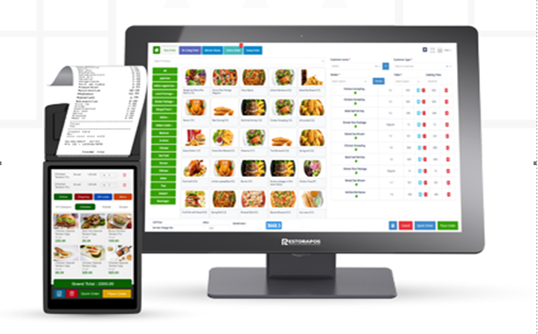

This application streamlines order and transaction process between cashier and customers. Its prioritisation is swiftness, simplicity, and efficiency in order-taking. It, unlike other available applications in market, is PINprotected and can only be accessed first by the manager and then subsequently by the assigned cashier. This double authentication ensures null mishandling of system itself and restaurant assets (viz. counter-cash embezzlement). A successful login provides a user friendly and an ordered interface for order-input along with order status, product details and delivery options (Brophy, 2021).

“One order management system, one database, one inventory. Without these you will never seem seamless to your customer.” — Andy Laudato, COO of The Vitamin Shoppe (Harper, 2021).

### Figure 2

*Operation in POS (**Miller, 2022**).*

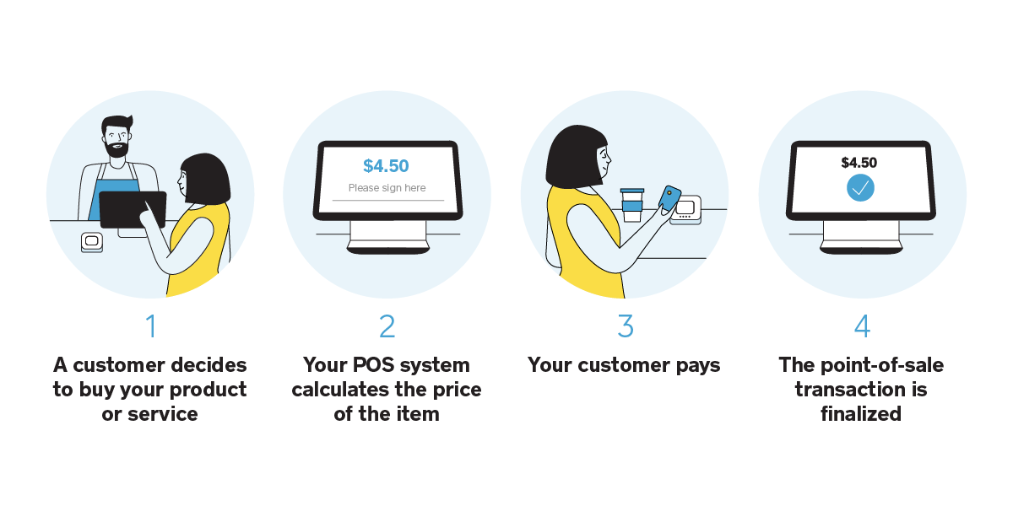

Figure 2 explains operation process of POS.

This system functions under *Create-Read-Update-Delete* (CRUD) application. The database stores restaurant staff’s credentials for login authentication, product details for customer’s query, and order details for delivery purpose and record. The recorded data is retrievable and mutable.

# Aim

Aim of this application is to take customer’s orders efficiently in a systematic manner for quick production in kitchen and swift delivery to consumers.

# Objectives

* Ensures security of staff account and restaurant-assets.
* User-friendly interface facilitates easy operation.
* Login protocol secures dashboard.
* Analyses sales by salesperson or product.
* Inputs via touchscreen, mouse, or keyboard.
* Track sales, taxes, employee performance and customer frequency.
* Automating accounting (Prajapati, 2020).
* Create better and less hectic working environment.
* Mitigate errors.
* Better customer service.
* Replaces traditional pen-paper order-taking method.
* Operation of POS in mobile devices for table-orders (Alice, 2022).

# Problem Statement

Traditional system of noting customer’s order in restaurant with pen-paper is not on par with current technologically developing time. Data organisation and storage are a hassle. Payment of the order can take several steps as indicated in figure 3 and many transactions are inconsistent due to mishandling of cash. Since taking orders manually takes a lot of time, kitchen staff starts production late and hence guests are serviced late too. Therefore, there is sever lack of coordination among staff-members. Many guests thereby are forced to wait longer for their turn.

This project solves the aforementioned problems by computerizing order process, which informs kitchen personnel instantly, thus saving time in both order-input as well as production and warrants quick food-delivery. The mandatory login of manager and then of cashier handles misuse of company assets. Easy-to-use UI enables hassle-free and correct orders input. Integrated database also secures history of orders and up-to-date details of staffs and products. Thereby, the system calculates transactions correctly, payment is instant (as shown in figures 3, 4) and guarantee lesser to no mistakes (POSportal, 2020).

### Figure 3

*Problems vs Solutions in POS*

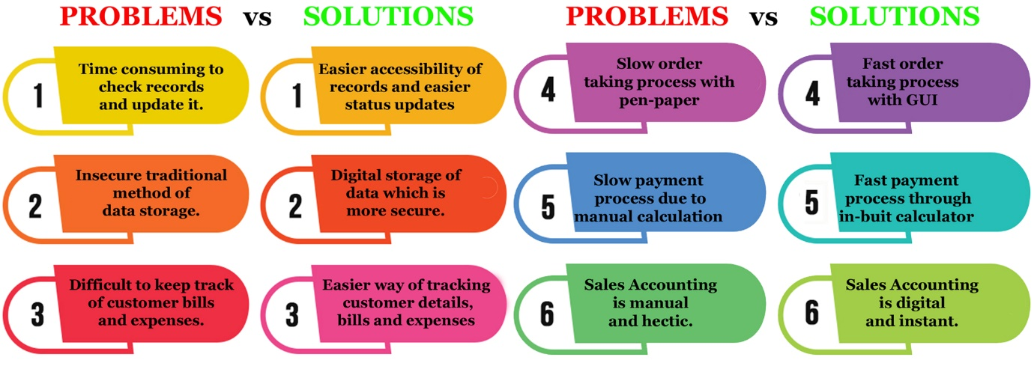

### Figure 4

*Traditional Payment vs POS’s Pay-at-the-Table (POSportal, 2020).*

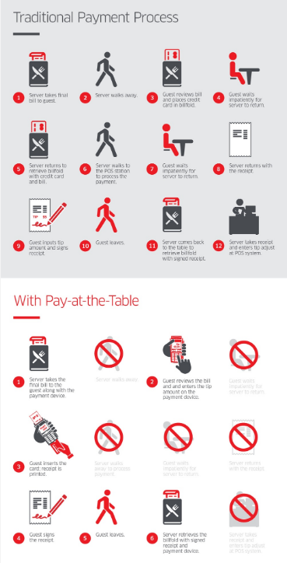

# Features

* Create and manage staff(s) profile
* Registration of employee only under superior’s validation
* Deletion of employee profile only by superior
* Supports multiple user accounts
* Staff login under manager’s permission
* Two-factor staff login verification
* Privacy of staff details
* Simple and user-friendly UI
* Allows multiple order without any calculation mistakes
* Observable order status
* Easy order modification
* Swiftness in order, billing, and transactions
* Swiftness in production and delivery (Alice, 2022).
* Takeaway and dine-in options (Nicasio, 2018).

Figure 5 presents 12 key features of a great POS system.

### 

### Figure 5

*Features of POS (Chalberg, 2022).*

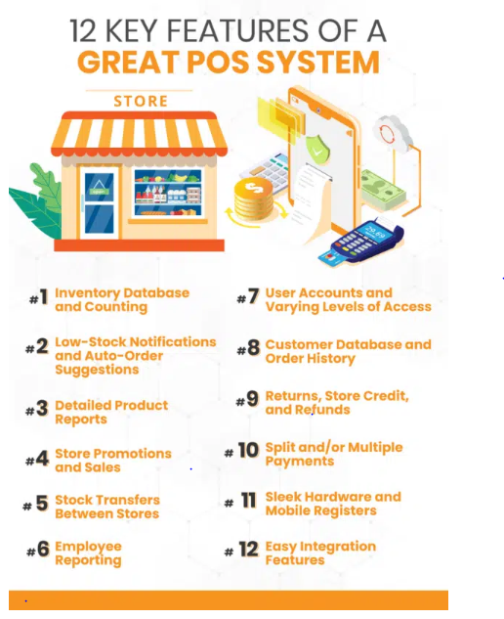

# Functional Requirements

Functional requirements that define what a software must do, what its features and functions are, as follows:

* Two-layer login verification
* Addition and modification of staff database
* Addition and modification of product database
* Delete data in database by only superior
* Categorize products
* Possibility of multiple orders
* Takeaway and eat-in option
* Live update of order status
* Digital calculation and billing (Morisio, 2013)**.**

# Non-Functional Requirements

Non-functional requirements that explain how the system should perform are as follows:

* **Usability:** Easy to use and self-explanatory GUI.
* **Security:**

1. Login within 10 seconds of correct pin-input.
2. Logout within 10 seconds after command.
3. Staffs are permitted to check only their credentials.

* **Performance:**

1. Transition among UIs should be within 10 second.
2. Button should return results with maximum lag of 5 seconds.
3. Accounting should not take more than 5 seconds.

* **Changeability of data:** Modification in database should be quick.
* **Capacity:** Stable performance for concurrent 200 orders.
* **Scalability:** Upgradable system.
* **Portability:** Operation in different Operating systemsand mobile devices as *Table-POS*.
* **Compatibility:** System requirement is not high.
* **Connectivity**

1. Notification to Kitchen should be within 10 seconds after ordering.
2. Replaces traditional pen-paper order taking system (Morisio, 2013)**.**

# Scope

Scope is defined collectively by all the preceding topics of aim, objectives, problem statements, features, functional requirements, and non-functional requirements. Figure 6 displays scope of POS system. The main scope of this program is digitisation of employee details, product details and accounting ensuring

* better management of restaurant resources
* employee registration by superior staff
* simplicity in creating, retrieving, editing, updating, and deleting data
* quick and easy order by touch or click on UI
* swiftness in calculation of transaction
* instant order-notification to kitchen
* faster workflow
* better customer service with less queue time for order and delivery
* more sales implying more earnings
* proper utilisation of workforce meaning more work done by limited staff compared to addition of more staff needed for the same amount of work in same timeframe while using traditional ordering method
* instant recording of sales compared to need of extra time and personnel for the same purpose in traditional method

### Figure 6

*Scope of POS* (*Talech, 2020*).

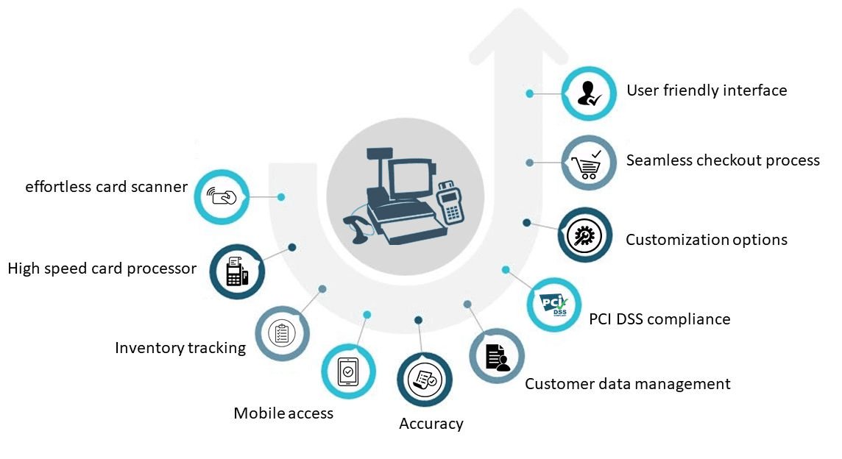

# Development Methodology

Development methodology refers to *Software Development Life Cycle* (SDLC) which provides steps to develop a software from scratch.

## Methodology

*Modern Waterfall Model*, also known as *Iterative Model*, is utilized for development of this software. It is used because of its step-by-step and simple to follow phases for novices in IT field. This method is suitable for virgin developers like us who just embarked on the field of *‘Software Engineering’*. Figure 7 presents all stages in this model.

### Figure 7

*Phases in Modern Waterfall method (**Singhal, 2021**).*

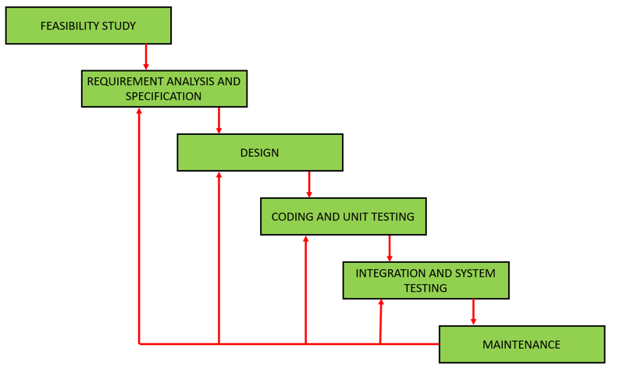

At first, a ‘Feasibility study’ was conducted by the developing team of the practicability of this software through discussions and research. After that followed ‘Requirement Analysis and Specification’ phase, which involved ‘Requirements Gathering and Analysis’, and ‘Requirement Specification’ creating a *Software Requirement Specification* (SRS) document, which documented functional and non-functional requirements, aim, objectives, features, problem statements, scopes, and details of software. Subsequently, a structured ‘Design’ was finalized iteratively through object-oriented approach considering various objects in problem domain and solution domain along with their relationships. Then, design was translated into source code using Python programming language in ‘Development’ phase to build a working software, which was unit tested and integrated incrementally in the following ‘Integration and System-testing’. The software was then ready to be released to users and regularly maintained in the final ‘Deployment and Maintenance’ stage (Nitika, 2018). Above phases were revisited as per need due to new user-requirements and feedbacks that could be thought plausible (Singhal, 2021).

Figure 8 displays all phases, along with their respective characteristics, of waterfall SDLC.

### **Figure** 8

*Phases and their characteristics of Waterfall Model* (Nitika, 2018).

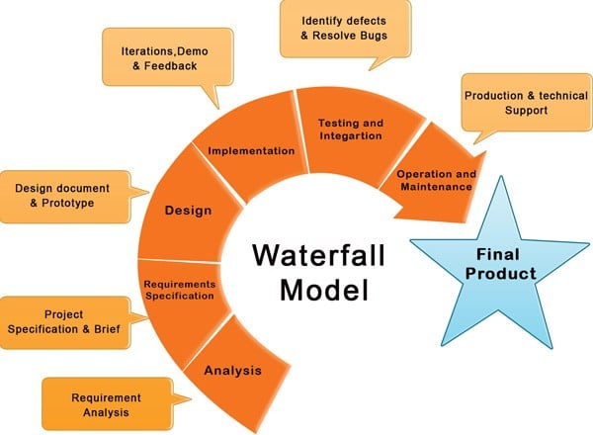

## Tools and Technologies

Several tools and technologies were used in the entire SDLC as shown in figure 9. They are:

* **Windows** and **Ubuntu** as working platforms,
* **MS Word** and **Adobe reader** for ‘Feasibility Study’ and ‘Requirement Analysis and Specification’ phase,
* **Figma, Adobe Photoshop, Adobe Illustrator** and **GIMP** for ‘Design’ phase,
* **Python** with **Tkinter-library** and **Visual Studio Code** for coding in ‘Development’ phase,
* **Sqlite3** for database in ‘Development’ phase,
* **Lucidchart** for conceptual diagram,
* **Git** and **Github** for version control,
* **Discord** for feedbacks and discussion,
* **Google search engine** for research,
* **MS Excel** for project planning.

### Figure 9

*Tools and Technology used in project*

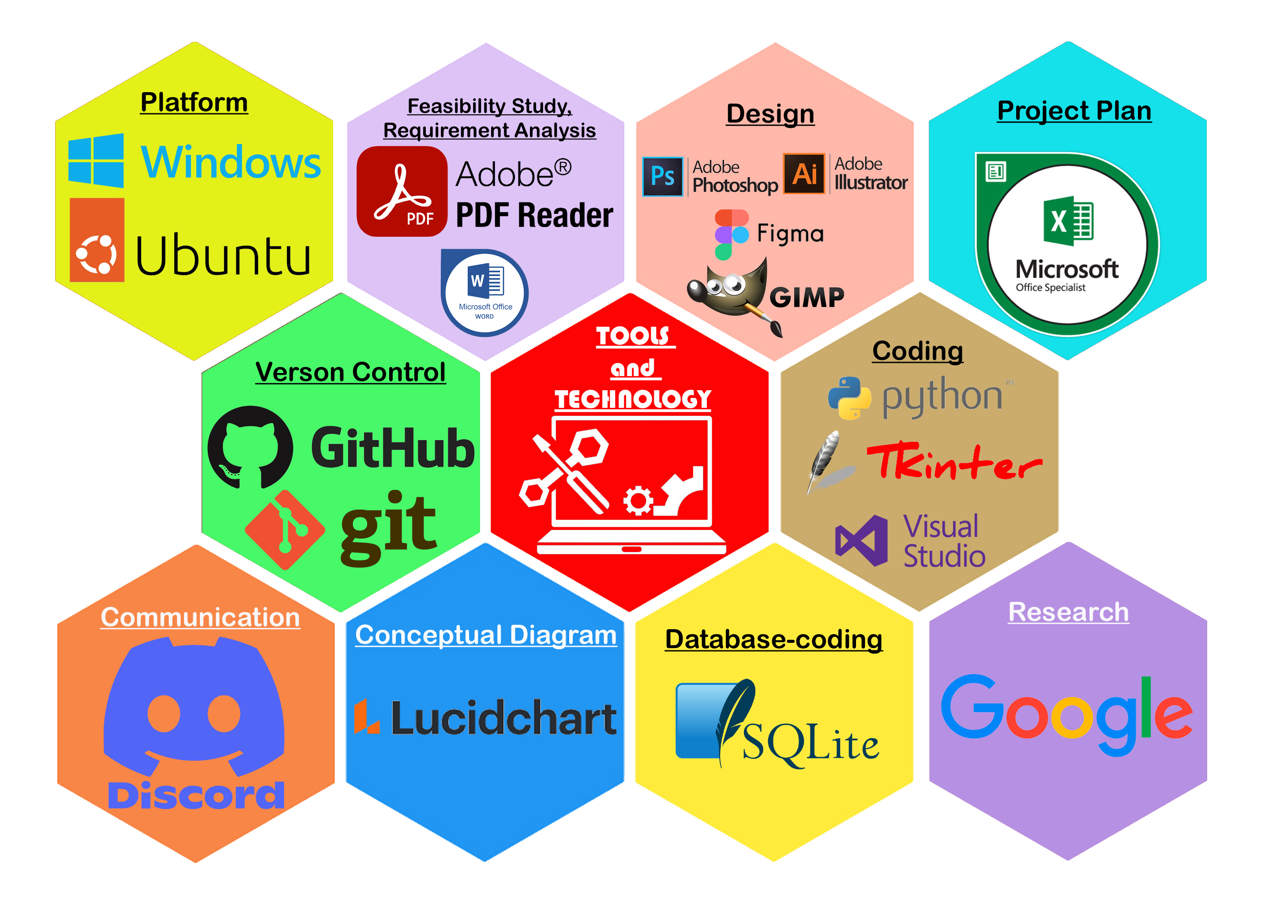

## Conceptual Diagram

Entity-Relationship Diagram explains the diagrammatic relationship between entities in a system. Figure 10 demonstrates ER diagram between entities in this project.

### Figure 10

*ER Diagram of POS*

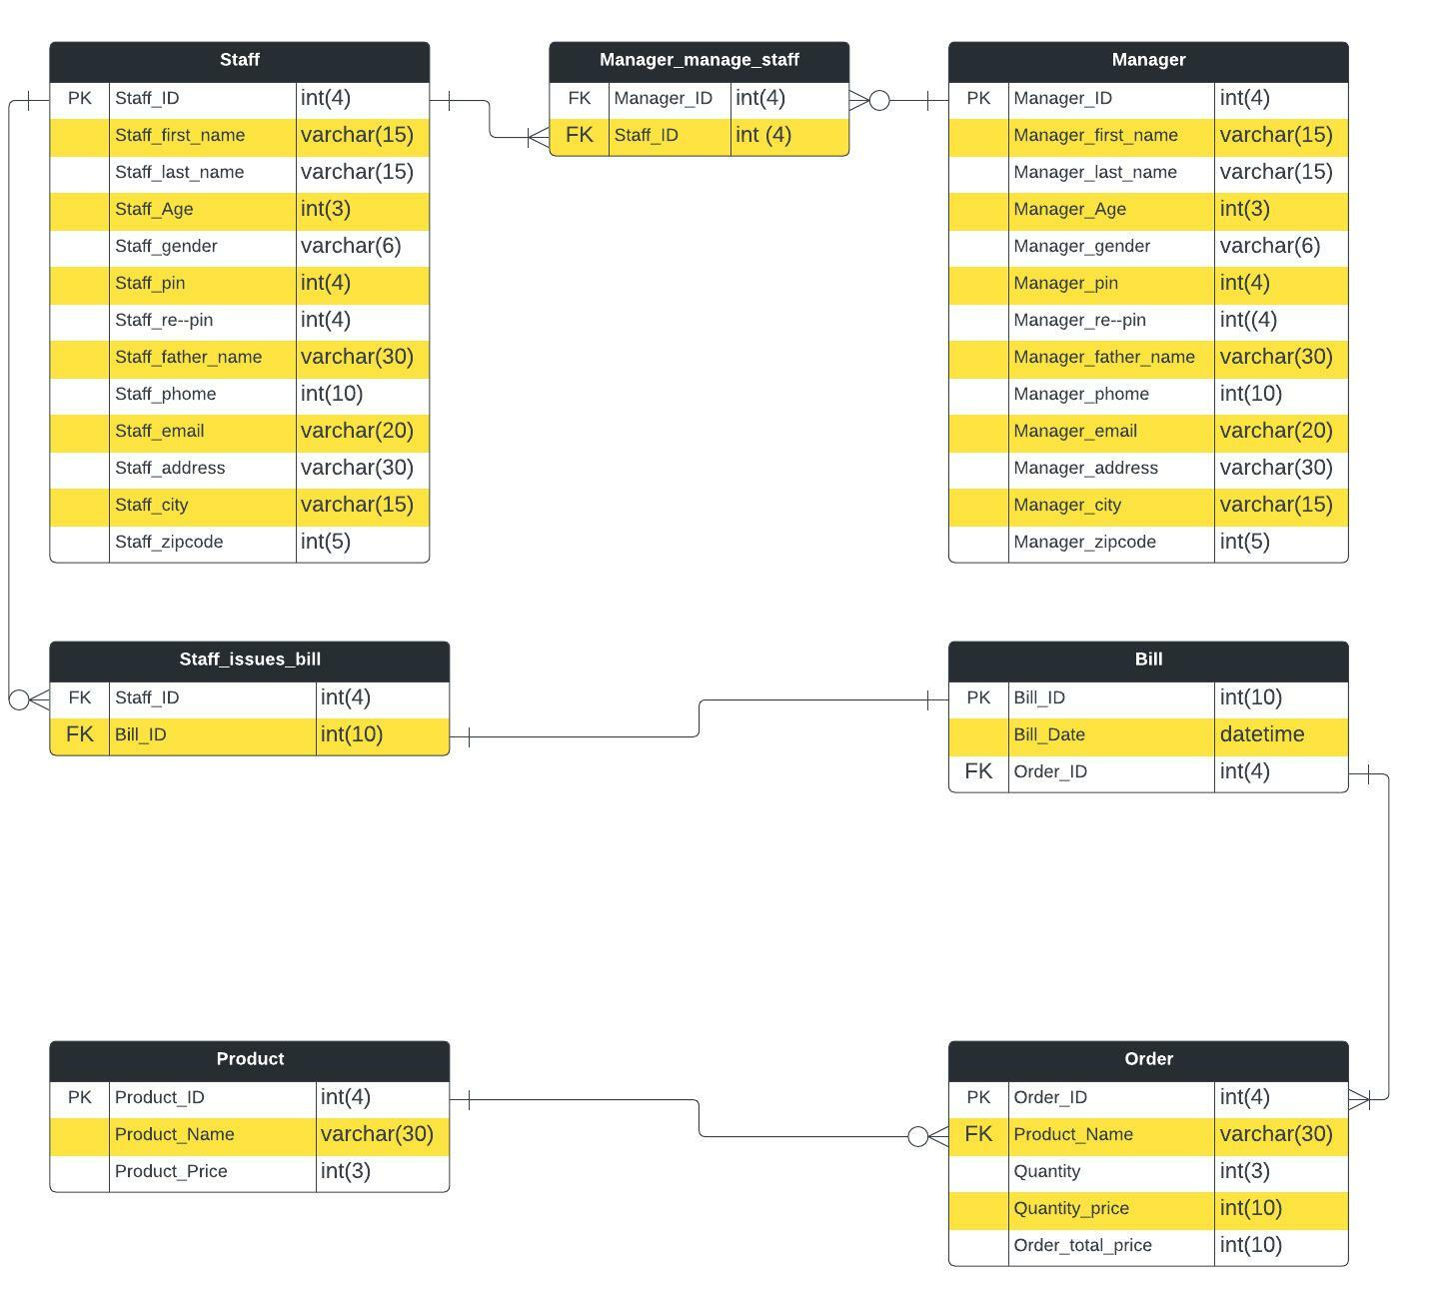

# System Architecture

This system is based on two-tier-architecture which separates its two components namely server and client into two different locations, in which client runs the presentation layer or user interface and server stores the data layer or data structure. It is also referred as ‘Client-Server Application’.

It is used because of its simplicity. In this software, manager enters data to be stored on database in server system. The client system can retrieve any data necessary from server to login or to take orders, can modify data like changing staff credentials, editing order or deleting data if necessary. These requests of client system are updated in server’s database, which can be again accessed through client system (PerfMatrix, 2019). Figure 11 presents a two-tier architecture.

### Figure 11

*Two-tier architecture* (Baabtra, 2022)

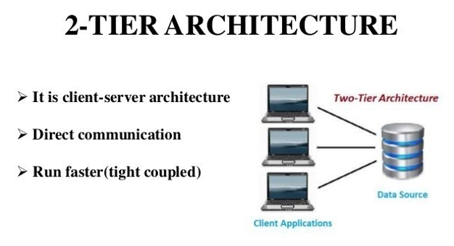

# Project Plan

A progress chart is vital in software engineering to track time, effort, and progress of the software development. The developing team recorded its progress plan using Gannt Chart for all phases of modern waterfall SDLC as informed in figure 12.

### Figure 12

*Gannt Chart for work progress*

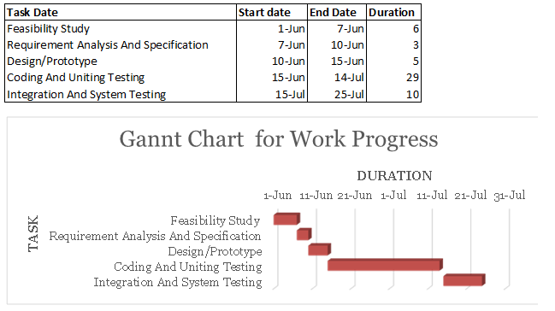

# Prototypes

Prototypes are essential to pave a distinctive path to build a GUI as per SRS document. Several prototypes were built before transforming them into source code. Several throw-away prototypes paved way for subsequent designs. This system is mirrored from the approved prototypes. Designs of this project are shown in figures 13-21.

### Figure 13

*Initial Throw-away prototype*

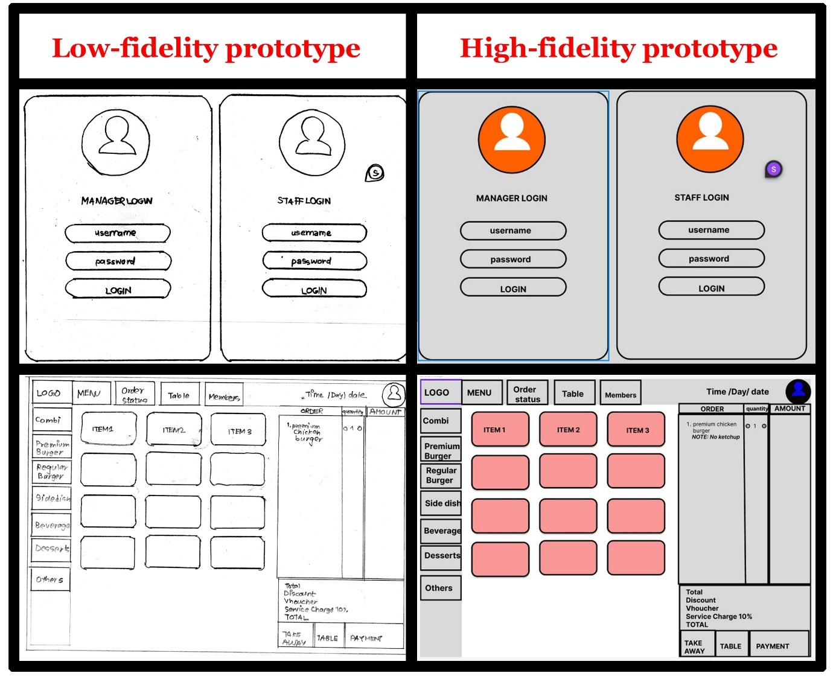

### Figure 14

*Manager Login*

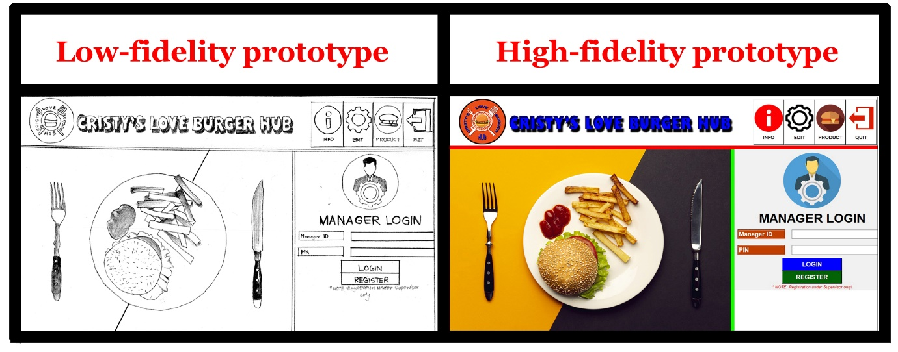

### Figure 15

*Staff Login*

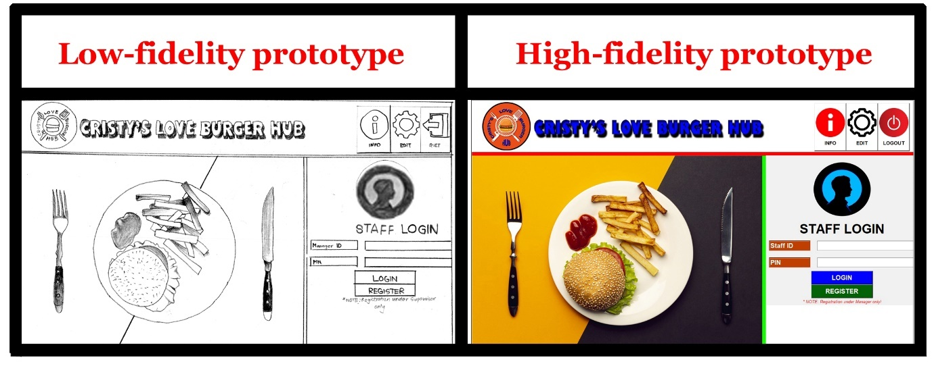

### Figure 16

*Product CRUD*

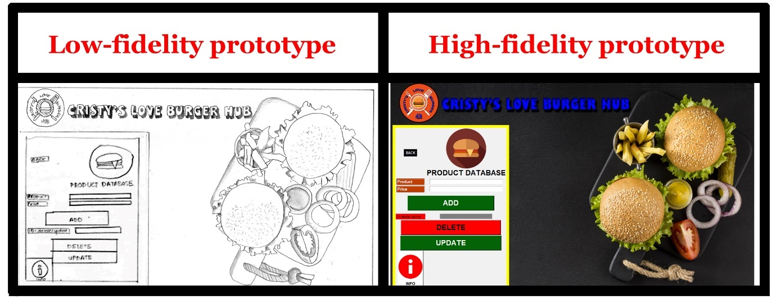

### Figure 17

*Manager Registration*

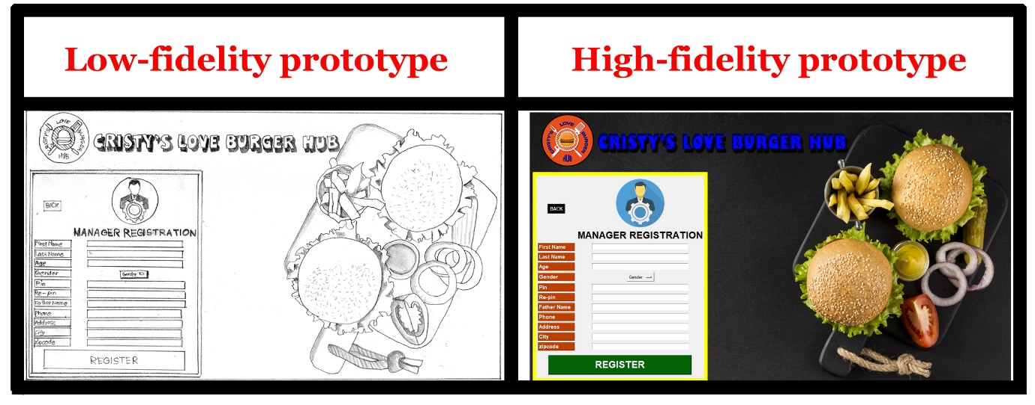

### Figure 18

*Staff Registration*

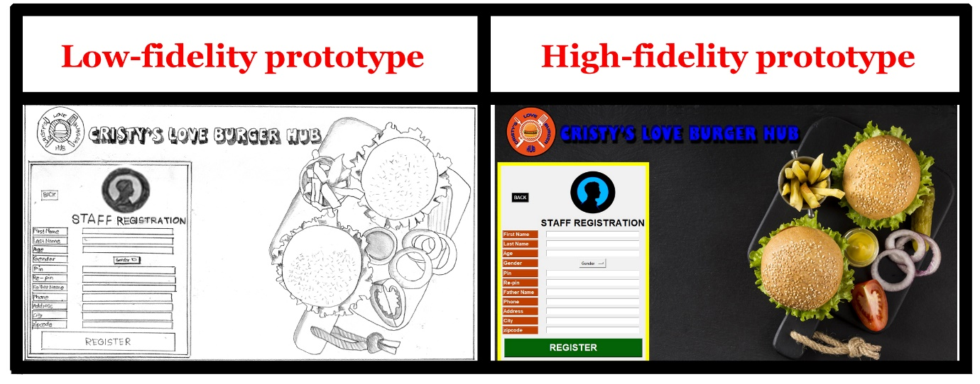

### Figure 19

*Edit Manager Data*

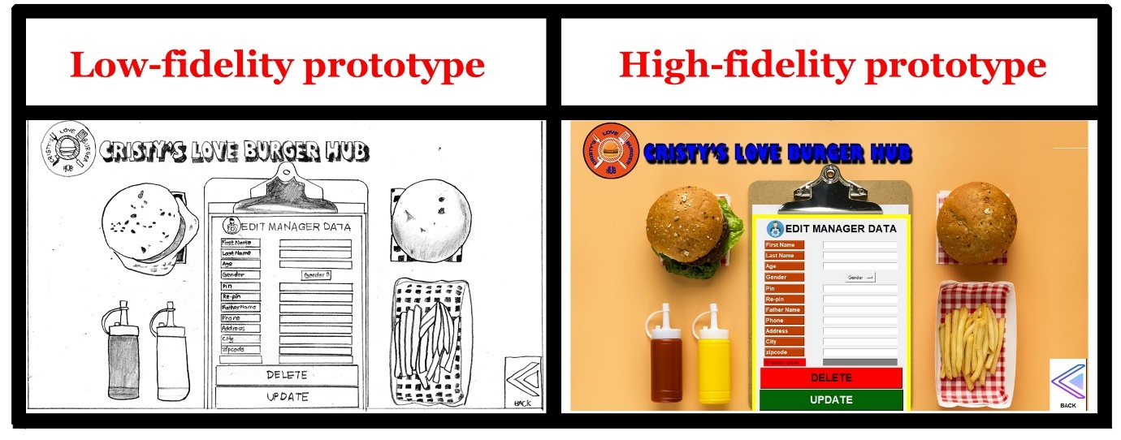

### Figure 20

*Edit Staff Data*

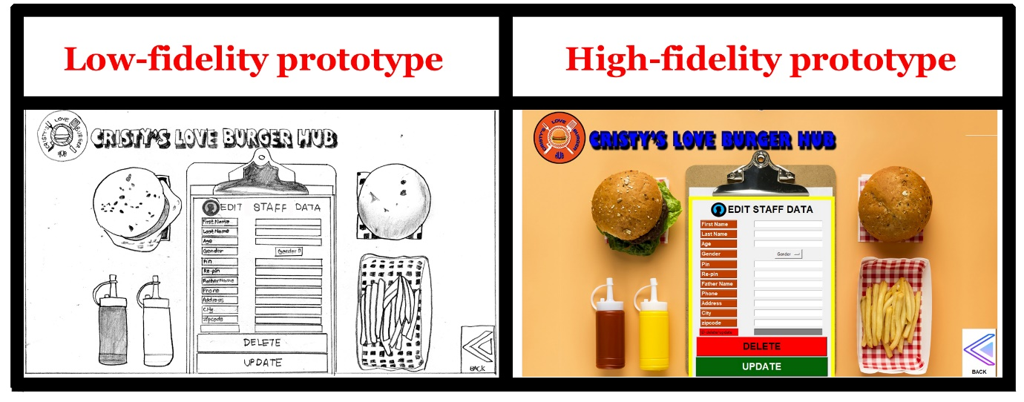

### Figure 21

*POS GUI*

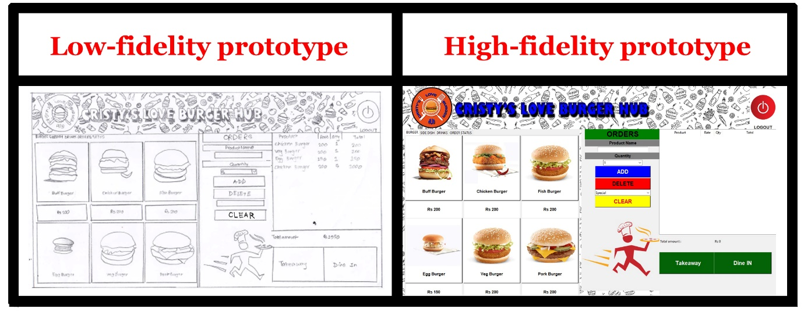

# Developed System

A working software was coded using Python with Tkinter library and Sqlite3 in a systematic and logical manner. The team members divided the workload according to their interest and forte. The team’s understanding of Python programming language with Tkinter GUI tools and Sqlite3 database were applied in coding to develop a fully functional application. The software can be divided into following parts for easy understanding.

## Login UI

Login UI allows a platform to securely login to the employee’s account through valid data entry. “REGISTER’ button checks staff’s authorization to register new employees and forwards to ‘REGISTER’ page after successful verification. Only supervisor can add new mangers while only managers can add new staffs. ‘INFO’ accesses database to view employee ID. ‘EDIT’ button has two functions. Firstly, it authenticates credentials of the employee to update their own data. Secondly, it allows superiors to change their subaltern’s data in instances they forget their pin or delete subordinate’s account if they resign. ‘*MANAGER LOGIN’* page has ‘QUIT’ button to exit the program and ‘PRODUCT’ button for CRUD functions of restaurant products for supervisor and managers. Proper message-box pops when commands are executed. ‘*STAFF LOGIN’* page contains ‘LOGOUT’ button for logged manager to sign-out. ‘STAFF LOGIN’ page can only be accessed after manager signs in to his/her account in ‘MANAGER LOGIN’ page. It is manager’s dashboard. Login pages are shown in figure 22 and 23 with code’s snippet in figure 24.

### Figure 22

*Manager Login*

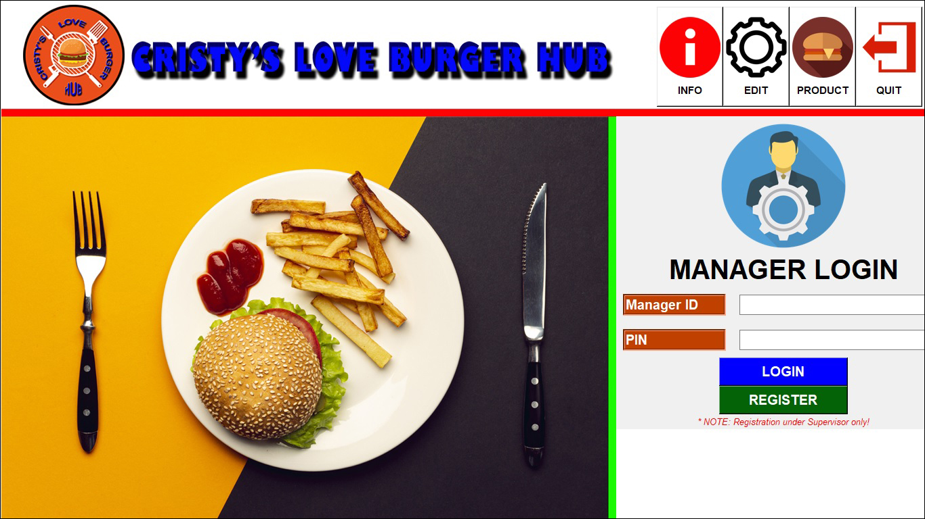

### Figure 23

*Staff Login*

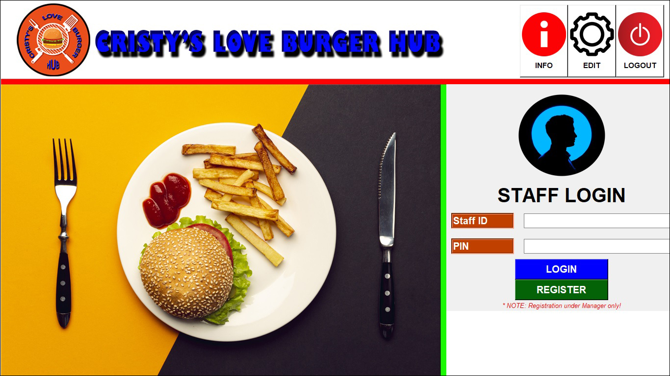

### Figure 24

*Login code*

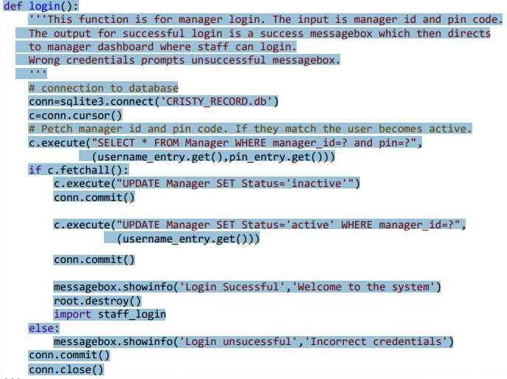

## Registration UI

Registration UI facilitates a platform to register new employees to the database by superiors. All the details are mandatory to be registered in the database. A successful entry results in a ‘success’ message-box while invalid entry prompts ‘failure’ message. ‘BACK’ button enables user to return backward to the previous page. ‘MANAGER REGISTRATION’ is accessed from ‘MANAGER LOGIN’ page while ‘STAFF REGISTRATION’ opens from ‘STAFF LOGIN’ page. Figures 25 and 26 display Registration pages with code’s snippet in figure 26.

### Figure 25

*Manager Registration*

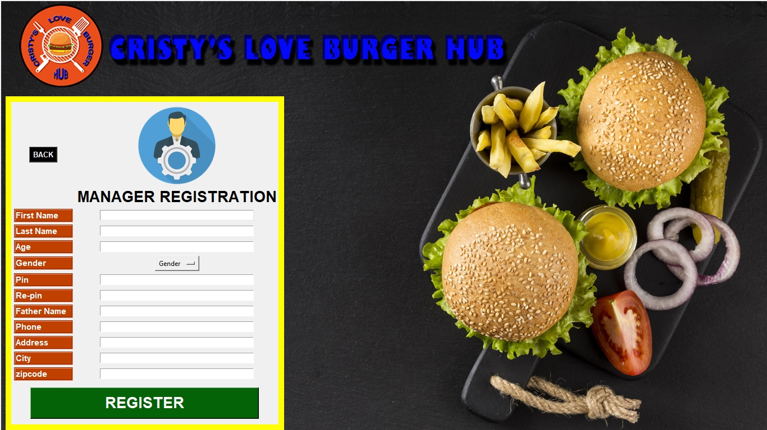

### Figure 26

*Staff Registration*

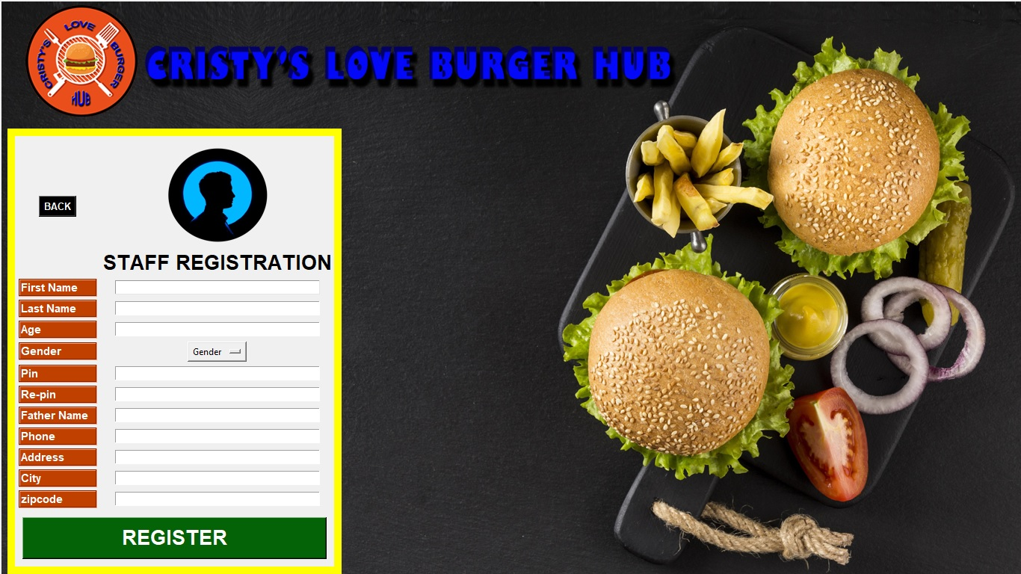

### Figure 27

*Registration code*

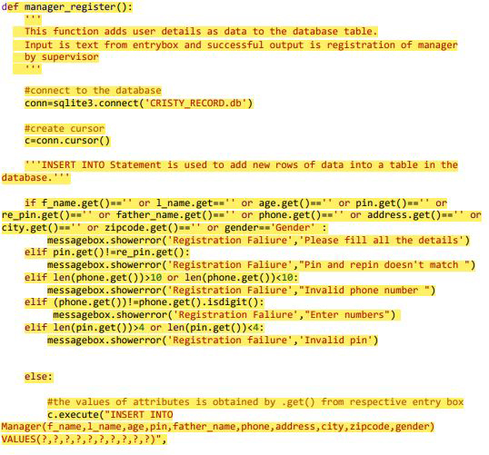

## Product Details UI

It is product’s CRUD page. It is accessible only to supervisor and managers from ‘MANAGER LOGIN’ page. Food items can be added, edited, or deleted in this interface. All fields are mandatory. Proper message-box prompts after each command. ‘BACK’ returns to previous page. Figures 28 and 29 represent its GUI and its code snippet respectively.

### Figure 28

*Product Details*

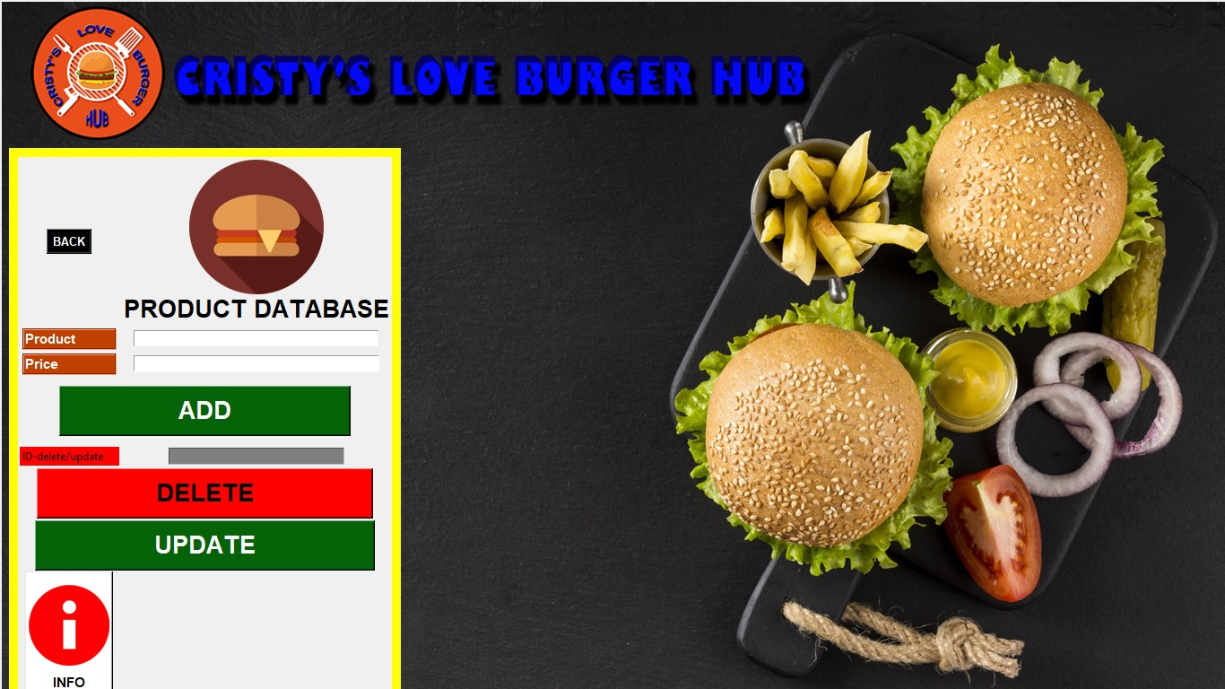

### Figure 29

*Product Details’ code*

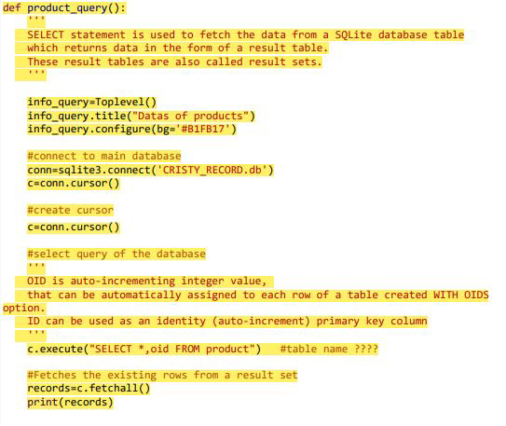

## Update/Delete UI

Employee can access this page to update their respective account after successful login. All fields are mandatory and must be valid. In case of resignation of the employee, superior staff can access this page to permanently delete the quitted employee’s records. Managers and staffs have their respective ‘EDIT’ page as shown in figures 30 and 31, with their code snippet in figure 32.

### Figure 30

*Edit Manager Data*

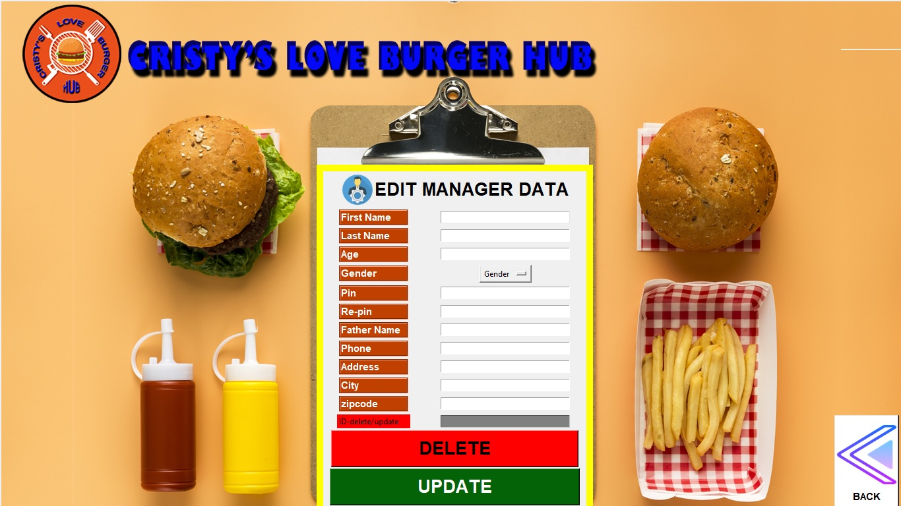

### Figure 31

*Edit Staff Data*

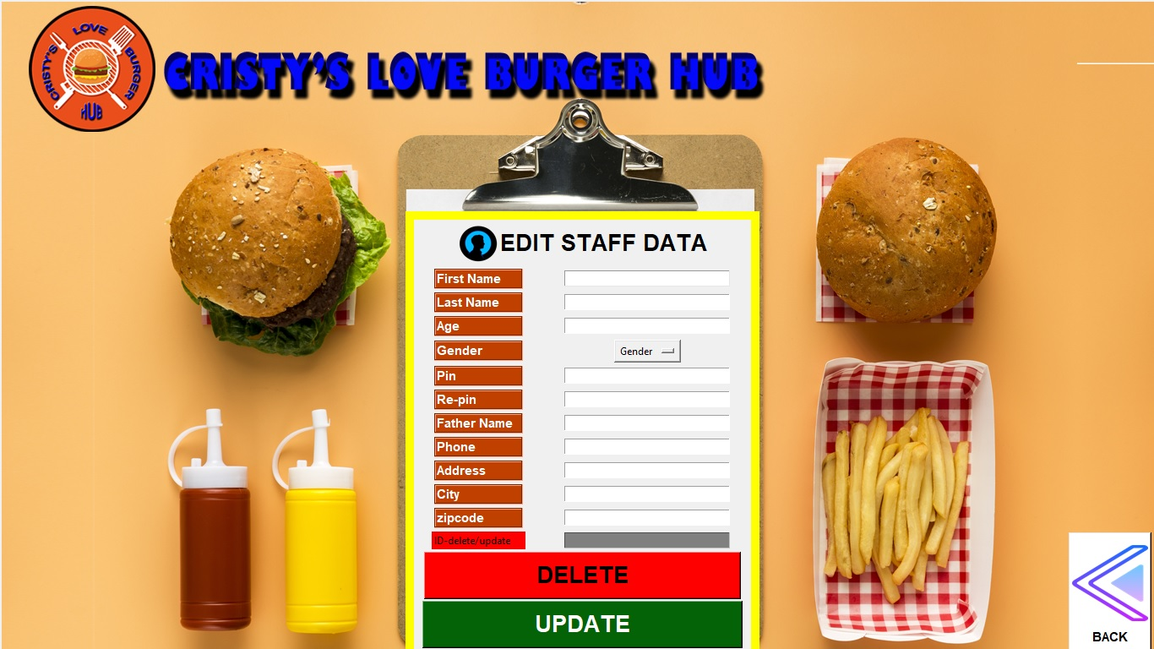

### Figure 32

Code of *Edit Data*

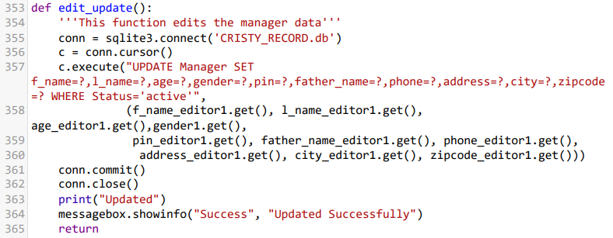

## POS UI

This page is the main order page of the system. Cashier takes order from the customers and complete transactions in this page. It consists of available restaurant products with price details in their respective category. The staff can add, read, edit, and delete customer’s order as per need. Accounting is automatic and accurate. Customers can choose to ‘EAT IN’ or ‘TAKE AWAY’. Staff can check the status of the order in ‘ORDER STATUS’ tab and update it as ‘complete’ when foods are delivered to the patrons. Staff can logout from their account after their shift is complete through ‘LOGOUT’.

Figures 33 and 34 shows the POS UI and its code’s snippet respectively.

### Figure 33

*POS UI*

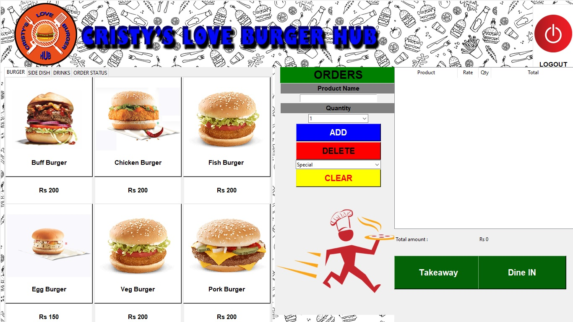

### Figure 34

*Code of POS UI*

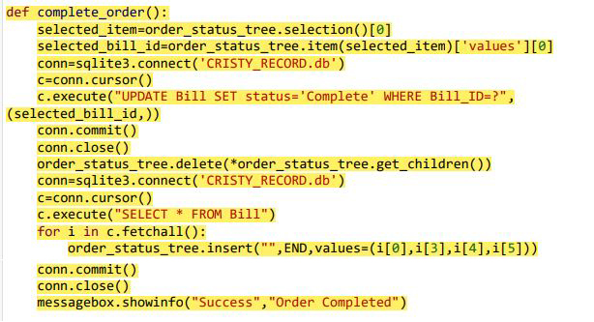

# System Testing

Black box testing was performed for system testing after the completion of coding to check its functionality as per SRS manual as shown in figures 35 to 43. Outputs were recorded to the test cases. Errors were corrected until all test cases were satisfied.

### Figure 35

*Manager Registration test*

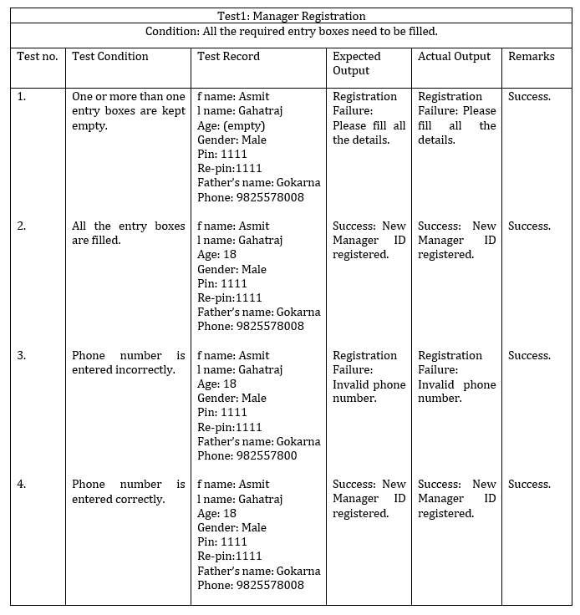

### Figure 36

*Manager Login test*

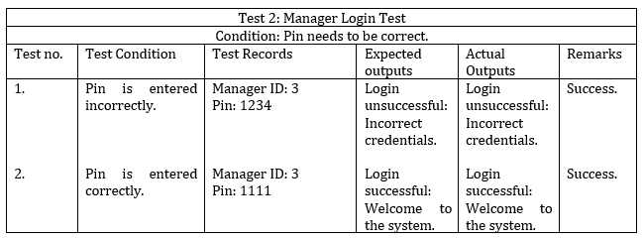

### Figure 37

*Staff Login test*

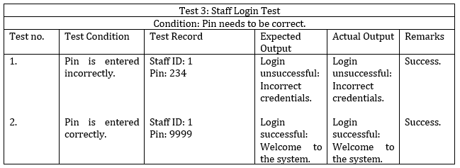

### Figure 38

*Staff Registration test*

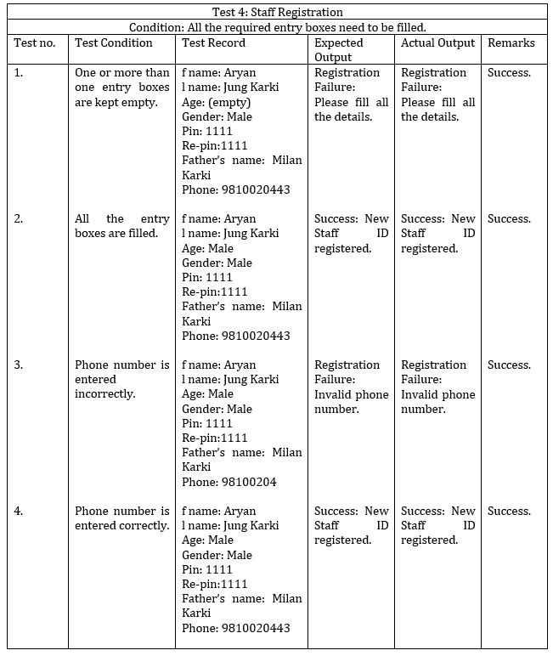

### Figure 39

*Manager CRUD test*

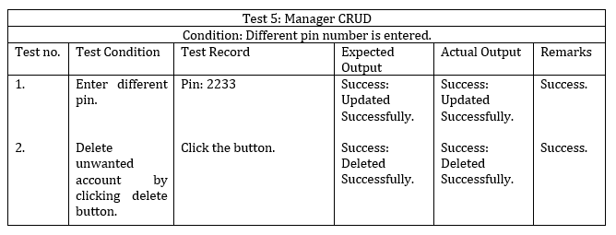

### Figure 40

*Staff CRUD test*

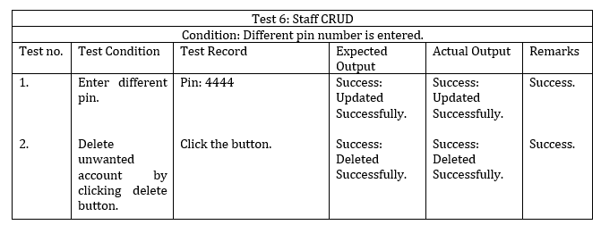

### Figure 41

*Logout test*

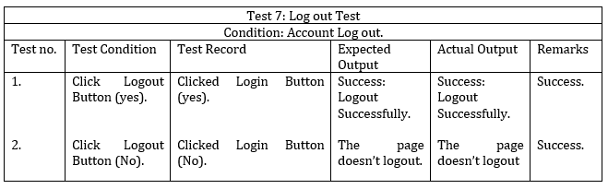

### Figure 42

*Order test*

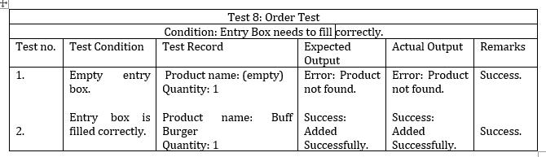

### Figure 43

*Order status test*

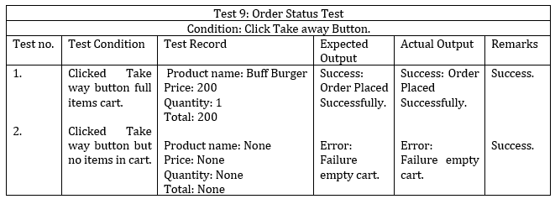

# Version Control

* **Github:** [xxxxxxx](https://github.com/mstacezro/ST4008CEM_32A_Project.git) as shown in figure 36.
* **Youtube:** xxxxxx

### Figure 36

*Version control of the project*

# Conclusion

The team engineered the final working product as per the requirement stated in user manual by integrating all the concepts learned in classroom from modules like Mathematics, Programming and Algorithm, and Software Design. Available technologies were used to their fullest.

This project solves the problem of traditional pen-paper order-taking in restaurants, focuses mainly on double-factor secure login and digital calculation of transactions. Both the functional and non-functional requirements as stated in the SRS are fully satisfied. System testing has shown positive results. All the bugs noticed during the implementation phase are already solved by the team with proper interaction and sharing of knowledge. The GUIs can be systematically accessed through correct credentials and user can be worry-free about their privacy. Through good teamwork the GUI is built to be attractive, presentable, simple, user-friendly, and self-describable.

The team has gained precious experience of developing a software from scratch for the first time, making us realize our severe lack of expertise in the IT field. Nevertheless, each effort in future will build us to be better in our careers by expanding our experiences. The desire to learn and grow through new challenges is our driving point. Friendly interaction between teammates and instructor, reminds us that knowledge expand by sharing. The team pledges to be better in IT field through open-minded learning, taking new challenges to create software as per need incorporating logics and following the IT ethics.

# References

Alice. (2022). *6 Key Features of a POS System | Alice POS*. Alice POS. Retrieved 6 June 2022, from <https://alicepos.com/6-key-features-of-a-pos-system/>.

Alice. (2022). *27 Advantages of a POS System | Alice POS*. Alice POS. Retrieved 6 June 2022, from <https://alicepos.com/27-advantages-of-a-pos-system/#:~:text=In%20general%2C%20a%20POS%20system,store%20for%20their%20next%20purchase>.

Baabtra, S. (2022). *2 tier and 3 tier architecture*. Slideshare.net. Retrieved 10 June 2022, from <https://www.slideshare.net/BaabtraMentoringPartner/2-tier-and-3-tier-architecture>.

Brophy, M. (2021). *What Is a Point-of-Sale (POS) System & How Does it Work?*. Fit Small Business. Retrieved 5 June 2022, from <https://fitsmallbusiness.com/what-is-a-pos-system/>.

Chalberg, M. (2022). https://koronapos.com/blog/pos-system-features/. Retrieved 7 June 2022, from <https://koronapos.com/blog/pos-system-features/>.

Harper, A. (2021). Jevera.software. Retrieved 6 June 2022, from <https://www.jevera.software/post/retail-order-management-system-in-general>.

Miller, F. (2022). Retrieved 6 June 2022, from <https://productivityland.com/five-examples-of-pos-systems-used-in-businesses/>.

Morisio, M. (2013). Softeng.polito.it. Retrieved 7 June 2022, from <https://softeng.polito.it/tongji/SE/ex/The-POS-system.pdf>.

Nicasio, F. (2018). Retrieved 6 June 2022, from <https://www.vendhq.com/blog/pos-features-for-retail-management-systems/>.

Nitika. (2018). *WHAT IS THE ROLE OF WATERFALL MODEL IN SDLC - Loginworks*. Loginworks. Retrieved 7 June 2022, from <https://www.loginworks.com/blogs/role-waterfall-model-sdlc/>.

POS, R. (2022). Restorapos.com. Retrieved 5 June 2022, from <https://restorapos.com/assets/img/sales%20page%20image/resturent%20pos%20software/image/restaurant-pos-software.png>.

POSportal. (2020). *POS Infographics Archives - POS Portal*. POS Portal. Retrieved 22 July 2022, from <http://www.posportal.com/posuniversity/infographics/>.

Prajapati, V. (2020). *What are the Objectives of a Point of Sale System?*. TechPrevue. Retrieved 7 June 2022, from <https://www.techprevue.com/objectives-point-sale-system/>

Singhal, P. (2021). *Software Engineering | Iterative Waterfall Model - GeeksforGeeks*. GeeksforGeeks. Retrieved 21 June 2022, from <https://www.geeksforgeeks.org/software-engineering-iterative-waterfall-model/>.

PerfMatrix. (2019). *Software Architecture and its types - 1-tier 2 tier 3 tier N-tier Architecture |*. PerfMatrix. Retrieved 9 June 2022, from <https://www.perfmatrix.com/software-architecture-and-its-types/>.

Talech. (2020). *Implementing Point of Sale Systems: Scope and Limitations - talech Thrive*. talech Thrive. Retrieved 6 June 2022, from <https://www.talech.com/blog/2020/07/15/resources-implementing-point-of-sale-systems-scope-and-limitations/>.